Matrix Elements

We use subscripts to identify specific elements of a matrix. In a 3x4 matrix called A such as

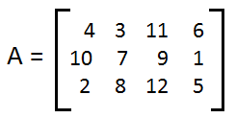

we identify A2,3 as the item in row 2 column 3. In our matrix A that is the value 9. We should note here that in mathematics we often write this as shown, namely, A2,3, whereas in many computer languages this indexing via subscripts would be written as A[2,3] or A(2,3), or even, in some cases, as A[2][3]. Our interest here is to understand how we use the subscript values to index particular elements of the matrix. Just to be sure, in our matrix A, element A3,2 is 8, A1,4 is 6, and A4,1 is invalid since there is no row 4.

One special concern here is where we start our indexing. In the example of matrix A we assumed that the top row is row 1 and the leftmost column is column 1. This is a natural assumption, and it is an assumption that is almost universally true in mathematics. However, especially in programming languages, it is not the only possibility. In some computer languages indexing starts at row 0 and column 0. For our matrix A, assuming that we start with row 0 and column 0, A2,3 would be 5 and element A3,2 would now be invalid since the rows are numbered 0, 1, and 2.

This change in indexing the rows and columns, changing from starting at 1 to starting at 0, is not the only way that we often alter our view of a matrix. Even in mathematics we have some traditional views of this that are different than the view that we presented above. For example, in the coordinate plane we label the points (x,y) in the following arrangement:

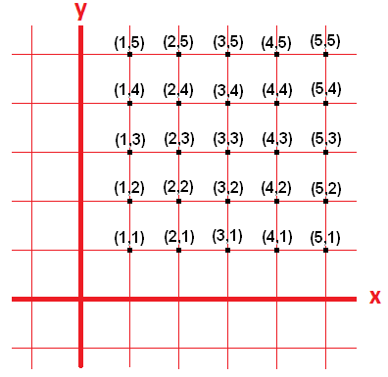

Note that the convention here is to reference the points by the coordinates (x,y) and that means that we give the column value first and the row value second. Thus, the point (3,2), in this context, is the third column, second row. Also, note that in this situation the numbering of the rows moves from the bottom upward. This is different from our original presentation of matrix A above.

The bottom line of this presentation is that we use subscripts to reference items in a matrix but that we need to be careful in explaining how we number the rows and columns and the order of the row and column references. By default, we will assume that the rows and columns are numbered starting at 1. Furthermore, unless otherwise specified, row numbers increase as we move down, column numbers increase as we move to the right. Finally, we assume that the specification is (row,col).